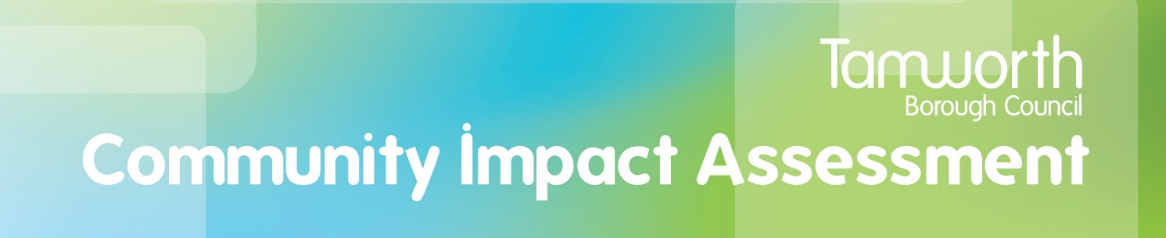

Guidance Notes

The legal context:

It is a legal requirement for local authorities to assess the equality and human rights impact of changes proposed or made to services. It is up to us as an authority to decide what form our Community Impact Assessment (CIA) may take and is about what is considered to be needed in a local authority’s area, in line with local factors such as demography and strategic objectives as well as with the national legislative imperatives.

The Public Sector Equality Duty requires the council to assess the impact on equality of strategies, policies and procedures. This Community Impact Assessment (CIA) is an internal process to ensure the impact assessment is undertaken.

Carrying out these impact assessments helps us as a public authority to ensure that, as far as possible, we are taking actions to meet the general equality duty placed on us by the Equality Act 2010, and to thus demonstrate that the three national equality aims are integral to our decision-making processes. These are:

- eliminating discrimination, harassment and victimisation;
- advancing equality of opportunity;
- fostering good relations.

The local context:

Our Community Impact Assessment goes further than just the protected characteristics and includes a number of other elements including safeguarding of the vulnerable, social inclusion, armed forces covenant, health and the environment. This is so we are thinking as carefully and completely as possible about all Tamworth groups and communities, including people who we may describe as vulnerable, for example due to low income or due to safeguarding concerns, as well as people in what are described as the nine ‘protected characteristics’ of groups of people in our population. We demonstrate equal treatment to people who are in these groups and to people who are not, through having what is termed ‘due regard’ to their needs and views when developing and implementing policy and strategy and when commissioning, procuring, arranging or delivering services.

Incorporating health, wellbeing and social inclusion means data can be collected and analysed more proactively. This equips service areas to have due regard to the three aims when considering and planning service changes, and to link in with climate change considerations.

The Community Impact Assessment also brings health and wellbeing more to the fore, as part of the work we do and through the work we do with partners to ensure that health is within all our policies. It demonstrates Tamworth Borough Council is working to address health inequalities within our communities.

Social inclusion includes the needs of veterans and serving members of the armed forces as a vulnerable grouping.

When to carry out the Community Impact Assessment

The Community Impact Assessment should be undertaken at timely points in the development and implementation of a proposed service change. This enables energies to be focussed on review, monitoring and ongoing evidence collection about the positive or negative impacts of a service change upon groupings in the community, and for any adjustments to be considered and made accordingly.

The Assessment should also be undertaken for all new policies, procedures and strategies as well as when these are reviewed.

Part 1 – Details and Part 2 – Summary of Assessment

To be completed in full by the Assessor.

Part 3 - Impact on the Community

Please consider each of the areas and provide a brief explanation of the impact on that group.

Protected characteristics

Age – consider children, young people, young people leaving care, people of working age, older people. Some people may belong to more than one group.
Disability – consider mental health conditions and syndromes, hidden disabilities including neuro diversity, physical and sensory disabilities, learning disabilities,
Gender reassignment – consider associated aspects; safety, caring responsibilities, potential for bullying and harassment
Marriage and Civil Partnership – consider associated aspects; caring responsibilities, potential for bullying and harassment
Pregnancy and maternity – consider safety, caring responsibilities, potential for bullying and harassment
Race – consider ethnicity, nationality, culture, language, Gypsy and traveller communities
Religion and Belief – consider Buddhism, Christianity, Hinduism, Islam, Jainism, Judaism, Nonconformists, Rastafarians, Shinto, Sikhism, Taoism, Zoroastrianism, and any others.
Sex – this can be viewed as related to gender. Consider safety, caring responsibilities, potential for bullying and harassment
Sexual Orientation - consider safety, caring responsibilities, potential for bullying and harassment.
Other social inclusion – consider caring responsibilities, those with an offending past, households in poverty, people for whom there are safeguarding concerns, people considered vulnerable, people with health inequalities, refugees and asylum seekers, rural communities, veterans and service members of the armed forces and their families.

Health and Wellbeing

The embedding of health into the Community Impact Assessment supports Tamworth Borough Council through evidence-based practice and a whole systems approach to promote, enable, and sustain the health and wellbeing of individuals and communities whilst reducing health inequalities.

- Will the proposal have a direct impact on an individual’s health, mental health and wellbeing?
For example; would it cause ill health, affect social inclusion, independence and participation? Will the proposal directly affect an individual’s ability to improve their own health and wellbeing? This could include; their ability to be physically active, to access food more easily, to change lifestyle in ways that are of positive impact for their health.

- Will the proposal indirectly impact on an individual’s ability to improve their own health and wellbeing?
For example, will it affect their ability to be physically active, choose healthy food, reduce drinking and smoking, access a means of mobility to local services and amenities?

- Will the policy have a direct impact on the community – social, economic and environmental living conditions that would impact health?
For example, would it affect transport, child development, education, employment opportunities, availability of green space or climate change mitigation? An example of this could be: an increase in the availability of warm homes would improve the quality of the housing offer in Tamworth and reduce the costs for households of having a warm home in the Borough. Often a health promoting approach also supports our agenda to reduce the level of carbon dioxide emissions and to reduce the impact of climate change.

- Will there be a likely change in demand for or access to health and social care services?
For example, Primary Care, Hospital Care, Community Services, Mental Health, Local Authority Services including Social Services. An example of this could be a new housing development in an area would affect demand for primary care and local authority facilities and services in that location and surrounding areas. If the housing development does not factor in consideration of availability of green space and safety within the public realm, further down the line there could be an increased demand upon health and social care services as a result of the lack of opportunities for physical recreation, and reluctance of some groupings to venture outside if they do not perceive it to be safe. Other factors to be considered could include:

Economic circumstances
- deprivation/financial concerns
- unemployment/poor education
- poor housing conditions (including geographical location).
Personal circumstances
- social isolation
- poor social skills
- self-neglect
- overcrowding
- those who are affected by anti-social behaviour.
Family circumstances
- child protection
- children in need
- children in care
- domestic abuse
- family members/carers with mental health/drug/alcohol problems
- family members/carers with a history of offending.

Part 4 Risk Assessment

For each of the areas identified with an adverse impact please detail the mitigating action to reduce the risk.

The risk measurement must be added onto Pentana.

Part 5 Action Plan & Review

Detail actions that you have identified in your CIA, which will eliminate discrimination, advance equality of opportunity, health and wellbeing and/or foster good relations.

The Action Plan and Review Date must be added onto Pentana.

Reviewed and approved by CMT July 2023

