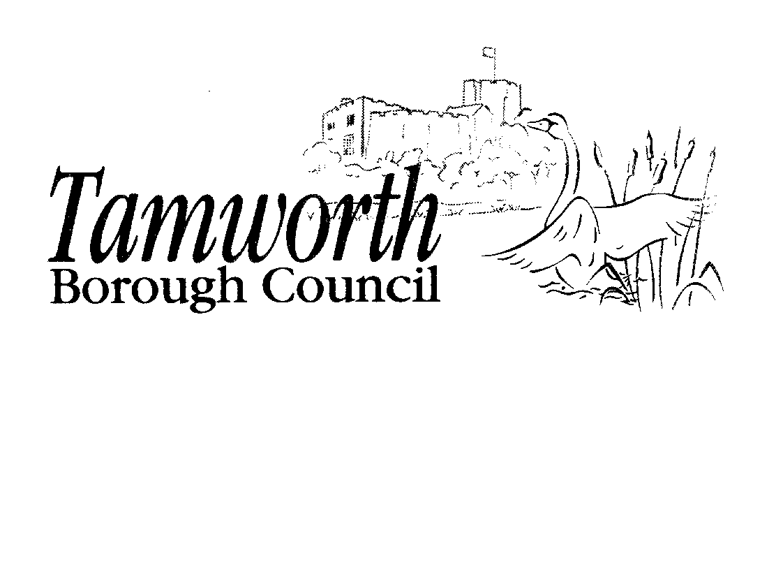

Licensing Act 2003
Club Premises Certificate Summary

'Club Details
Name of club in whose name this certificate is granted and relevant postal address of club

Tamworth Castle Bowling Club
2 The Green, Ladybank, Tamworth, Staffordshire, B79 7NB Telephone - 01827 311205
If different from above, the postal address of club premises to which this certificate relates, if any, or if none, ordnance survey map reference or description

Tamworth Castle Bowling Club
2 The Green, Ladybank, Tamworth, Staffordshire, B79 7NB Telephone - 01827 311205
Qualifying club activities authorised by the certificate

Supply of Alcohol for Members & Guests
L -
Supply of Alcohol
Where the club premises certificate is time limited the dates

This club premises certificate is not time limited

Club Premises Certificate Number | PREM/05/0145

The times the certificate authorises the carrying out of qualifying club activities
Supply of Alcohol for Members & Guests L Supply of Alcohol
Monday to Saturday Sunday
10:00 - 23:00 hours
12:00 - 22:30 hours
Good Friday
12:00 - 22:30 hours
Christmas Day
The hours fixed by or under the rules of the club in accordance with the following conditions:
- the hours fixed shall not be longer than 6½ hours and shall not begin earlier than 12 noon nor end later than 22:30 hours;
- there shall be a break in the afternoon of not less than 2 hours which shall include the hours from 15:00 to 17:00; and
- there shall not be more than 3½ hours after 17:00.
New Year's Eve (except Sunday) New Year's Eve (Sunday)
New Year's Eve
10:00 - 23:00 hours
12:00 - 22:30 hours
From the end of permitted hours on New Year's Eve to the start of permitted hours on the following day (which would be 10:00 hours if New Year's Day falls on a weekday, or 12:00 hours if a Sunday)
The opening hours of the club

Hours Premises are Open to the Public

0 Hours Premises are Open to the Public

Not applicable
Where the certificate authorises supplies of alcohol whether these are on and / or off supplies

For consumption on the premises and
For consumption off the premises

State whether access to the club premises by children is restricted or prohibited

Restricted in accordance with the provisions of the Licensing Act 2003

