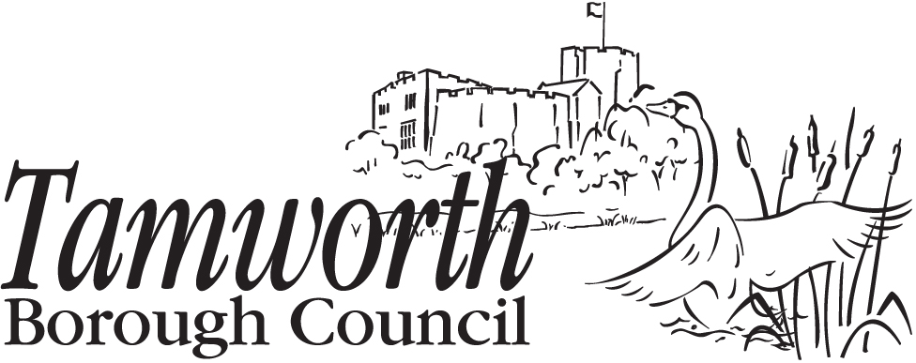

LOCAL CODE OF CONDUCT COMPLAINT FORM
Your details

- Please provide us with your name and contact details

Title:
First name:
Last name:
Address:
Daytime telephone:
Evening telephone:
Mobile telephone:
Email address:

Your address and contact details will not usually be released unless necessary or to deal with your complaint.

However, we will tell the following people that you have made this complaint:

- the member(s) you are complaining about
- the Monitoring Officer of the authority

We will tell them your name and give them a summary of your complaint. We will give them full details of your complaint where necessary or appropriate to be able to deal with it. If you have serious concerns about your name and a summary, or details of your complaint being released, please complete section 6 of this form.

- Please provide us with the name of the member(s) you believe have breached the Code of Conduct and the name of their authority:

Title | First name | Last name | Council or authority name

- Please explain in this section (or on separate sheets) what the member has done that you believe breaches the Code of Conduct. If you are complaining about more than one member you should clearly explain what each individual person has done that you believe breaches the Code of Conduct.

For example:

- You should be specific, wherever possible, about exactly what you are alleging the member said or did. For instance, instead of writing that the member insulted you, you should state what it was they said.
- You should provide the dates of the alleged incidents wherever possible. If you cannot provide exact dates it is important to give a general timeframe.
- You should confirm whether there are any witnesses to the alleged conduct and provide their names and contact details if possible.
- You should provide any relevant background information.

Please provide us with the details of your complaint. Continue on a separate sheet if there is not enough space on this form.

Only complete this next section if you are requesting that your identity is kept confidential

- In the interests of fairness and natural justice, we believe members who are complained about have a right to know who has made the complaint. We also believe they have a right to be provided with a summary of the complaint. We are unlikely to withhold your identity or the details of your complaint unless you have good reason to believe that:

Your reasons will be considered by the Council’s Corporate Information Security Officer.

Please note that requests for confidentiality or requests for suppression of complaint details will not automatically be granted. If your request for confidentiality is not granted, we will usually allow you the option of withdrawing your complaint.

However, it is important to understand that in certain exceptional circumstances where the matter complained about is very serious, we can proceed with an investigation or other action and disclose your name even if you have expressly asked us not to.

Please provide us with details of why you believe we should withhold your name and/or the details of your complaint:

Additional Help

- Complaints must be submitted in writing. This includes electronic submissions. However, in line with the requirements of the Disability Discrimination Act 2000, we can make reasonable adjustments to assist you if you have a disability that prevents you from making your complaint in writing.
We can also help if English is not your first language.
If you need any support in completing this form, please let us know as soon as possible.

You must submit your complaint to:

The Monitoring Officer
Tamworth Borough Council
Marmion House
Lichfield Street
Tamworth
B79 7BZ

For assistance please call Democratic Services 01827 709 264.

e-mail: members-complaints@tamworth.gov.uk

Post in an enveloped marked Private & Confidential to: Chair of the Assessment Sub-Committee.

- Equality monitoring questions

The information requested in this part of the form is used for monitoring purposes only.

Please tell us which complainant type best describes you:

Member of the public
An elected or co-opted member of an authority
An independent member of the standards committee
Member of Parliament
Local authority monitoring officer
Other council officer or authority employee
Other ( )

Please place a tick or cross in the appropriate boxes:

Gender: |  | Male |  | Female
Ethnic Origin: |  | Bangladeshi |  | Chinese |  | Pakistani
 |  | Black African |  | Indian |  | White
 |  | Black Caribbean |  | Irish
 |  | Others (Please specify)

Disability?

Do you consider yourself disabled? |  | Yes |  | No

If yes, please give an outline of the nature of your disability:

