Notice under The Local Authorities (Executive Arrangements) (Meetings and Access to Information) (England) Regulations 2012 Paragraph 10;

The making of the decision to update changes to committee places which was due to be made by Council on 23rd May is urgent and cannot reasonably be deferred because the council’s committee membership needs to be agreed so that the formal council annual diary can be implemented.

Tamworth Borough Council is therefore unable to comply with the requirements under The Local Authorities (Executive Arrangements) (Meetings and Access to Information) (England) Regulations 2012 Paragraph 10 in respect of Publicity in connection with the intention to make a key decision.

Tamworth Borough Council has taken the following steps to comply with the requirements under The Local Authorities (Executive Arrangements) (Meetings and Access to Information) (England) Regulations 2012 Paragraph 10 in respect of the general exception

- The Proper Officer (Deputy Chief Executive) Anica Goodwin, can confirm that the Group Leaders, Councillor P Turner, Councillor C Dean and Councillor D Cook and Independent Councillor R Kingstone, have been notified in writing of the need to allocate Councillor Ben Price to sit on Audit & Governance Committee, Councillor D Cook to sit on Planning and Councillor T Jay to sit on Statutory Officer Conduct Committee.

- The Proper Officer (Deputy Chief Executive) confirmed that the Chair of the Scrutiny Committee, Councillor D Cook has been notified in writing of the need to allocate Councillor Ben Price to sit on Audit & Governance Committee, Councillor D Cook to sit on Planning and Councillor T Jay to sit on Statutory Officer Conduct Committee.

- The Proper Officer has ensured that at least 5 clear days will have elapsed
from the date of this notice prior to the decision been made on Tuesday 18th July

- The Proper Officer has made arrangements for this notice to be made available at the Council Offices at Marmion House, Lichfield Street, Tamworth, B79 7BZ and on the Council’s website;

Notices under The Local Authorities (Executive Arrangements) (Meetings and Access to Information) (England) Regulations 2012 | Tamworth Borough Council

I am therefore satisfied that The Local Authorities (Executive Arrangements) (Meetings and Access of Information) (England) Regulations 2012 paragraph 10 has or will have been complied with.

Signed
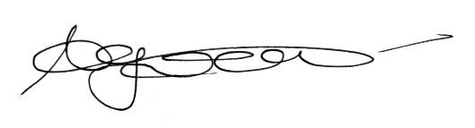

………………………………………………………………..
Anica Goodwin
Deputy Chief Executive Officer

Dated 2nd June 2023

