**How to apply online for a postal vote**

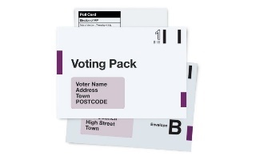A postal vote is when you are sent a postal ballot pack ahead of polling day and you return your ballot paper to the council offices in the post.

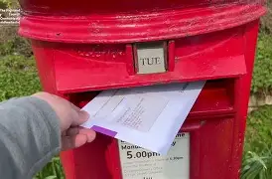

What will I need to apply for a postal vote online:

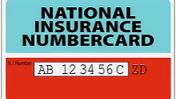Your National Insurance number (NINO) & Date of Birth (DOB)

(You can find your NINO on payslips, letters about tax, pensions and benefits)

 A person writing on a piece of paper



A piece of **plain white paper** and a **black pen**. You will need to photograph your signature.

Applying for a postal vote online only takes a few minutes

Apply for a postal vote

GOV.UK Image (White lettering on a blue background).Go to <https://www.gov.uk/apply-postal-vote>

Click Start Now

You will be asked questions including;

Are you registered to vote and where?

Your name and has it been changed?

Continue button Where do you want your postal vote sending and how long for?

After you have completed each question press ‘continue’

Signing and uploading your signature

Sign your name in **black ink** on **plain white paper**

It must be a handwritten signature 

Example signatures. 

Tick on signature on plain white background. 

Cross on signature on lined paper. 

Take a photo of your signature

* In focus
* No shadows
* Right way up
* No background/edge

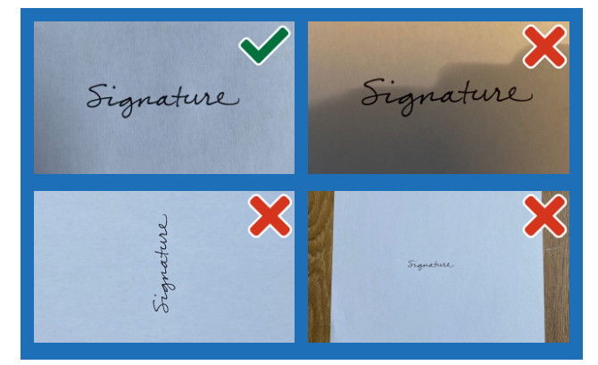

Once photogtraphed, upload your signature



1. Choose a file to uplaod button. ‘Drag and drop’ your image into the box or click ‘Choose a file to upload’ and select it from your device.
2. Select ‘Continue’. You should see an image of your signature. Check that it meets the requirements.

Continue button

1. Check and submit your signature, or cancel and upload another one if it is not right.

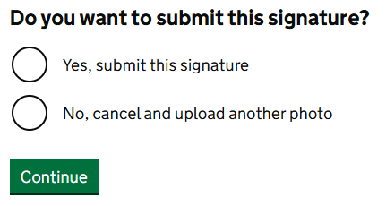

After uploading, your signature will be stored securely and matched each time you vote. Your vote might not be counted if the signatures are very different.

Example of screen to enter contact details e.g. email address and phone number. 
If you wish to be contacted by email or telephone, enter your details here. If not untick the boxes

Check your details then press

 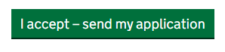  
If you need to amend any details click ‘change to edit’

Once submitted the Electoral Registration Officer will contact you shortly to confirm if your application has been accepted or if further information is requried.

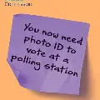

If you don’t reapply your postal vote will be cancelled, and you will revert to a polling station voter. You will need an accepted form of photo ID to vote in person.

**What if I don’t know my National Insurance number**

You can find your NINO on payslips, letters about tax, pensions and benefits.

If you cannot find your NINO click ‘I cannot provide my National Inusranvce number’ and explain the reason why. You will be asked ‘what is your position’, most people will choose ‘none of these’. You will be asked if you can provide evidence to verify your idenity, such as a passport or driving licence.

**What if I cant write my signature (Signature Waiver)**

You will be asked if you can write your signature, that can be matched each time you vote, if this is not the case select ‘no’. Select the reason you cannot sign and press continue. Then select whether someone has assisted you with your application, if so enter their details.

**I cannot upload my signature**

If you cannot upload an image - download, print out and fill in a paper form <https://www.gov.uk/government/publications/apply-for-a-postal-vote>.

Send it to:

Electoral Registration Officer

Tamworth Borough Council

Marmion House

Lichfield Street

Tamworth

Staffordshire

B79 7BZ

**Easy Read Instructions** [**https://assets.publishing.service.gov.uk/media/65b12752f2718c000dfb1c93/Postal_vote_online_application_guide.pdf**](https://assets.publishing.service.gov.uk/media/65b12752f2718c000dfb1c93/Postal_vote_online_application_guide.pdf)